Malatsi Koketso Alex

[Koketsoalex6@gmail.com](mailto:Koketsoalex6@gmail.com)

**Clipboard Health Quality Analyst Case Study**

|  |  |
| --- | --- |
| INDEX | |
| **TOPIC** | **PAGE** |
| Brett Account Analysis | 2-4 |
| Brett Account Finding And Analysis | 4-6 |
| Brett Account Questions | 6-8 |
| Ron McClain’s Account Analysis | 8-10 |
| Ron McClain’s Account Finding And Analysis | 11-13 |
| Ron McClain’s Account Questions | 13-14 |
|  |  |

**CASE 1: BRETT ACCOUNT DEACTIVATION ANALYSIS.**

1. **Subject**: Mail To E-Connect Management.

**Time And Date**: 3:18PM-17 December 2022.

**Issue**: Account Deactivation.

**Causes** : Accidentally cancelled morning appointment due to car problems which lead to the ESP to forget to cancel their shift in a timely manner.

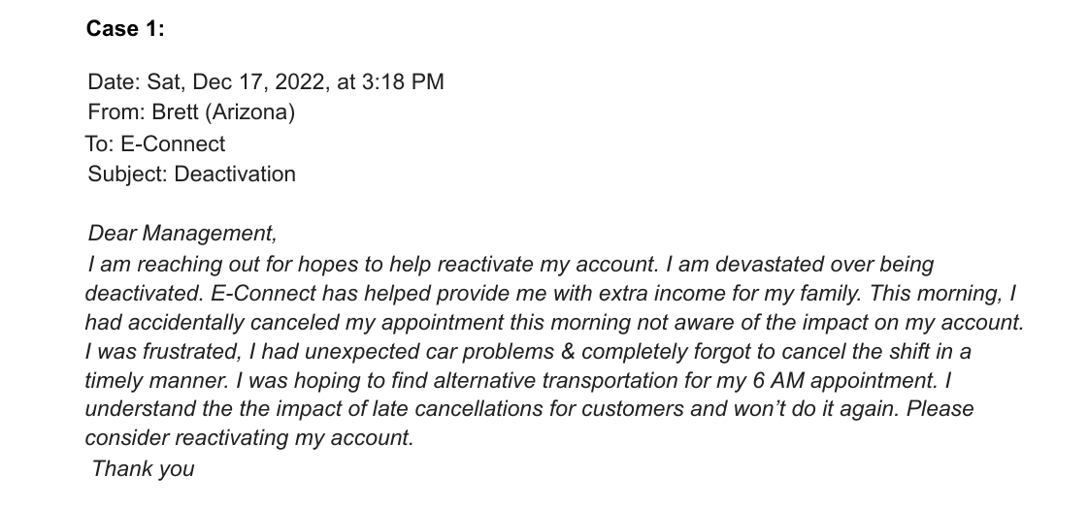

1. **Subject:** Brett Support Interactions.

**Time And Date:** 17 December 2022-Multiple Timestamps.

**Issues:** Account Deactivation.

**Causes:** Intentionally or/and accidentally cancelling an appointment.

December 17 2022- 06:39am

Brett via messaging

“My phone died and wasn’t able to notify being late to work. I immediately cancelled my appointment that left me to be deactivated”.

Brett via messaging

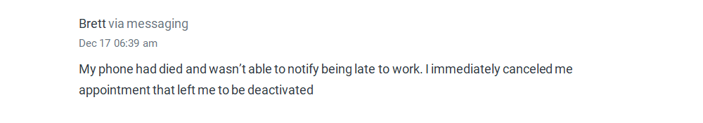

17 December 2022 – 06:42am

“Thank you I don’t agree with attendance policy”

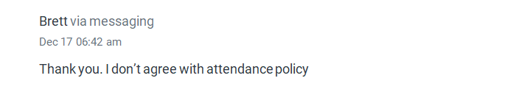

Joy Gullaba via message

17 December 2022- 06:44am

“Did you already fill out the dispute form”

Brett via messaging

17 December 2022 – 06:45am

“No I didn’t I’m not sure how to go about it”

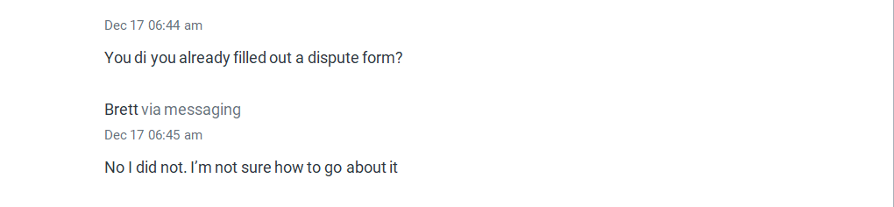

Brett via messaging

17 December 2022 – 06:48am

“Yes I accidentally cancelled my appointment ”.

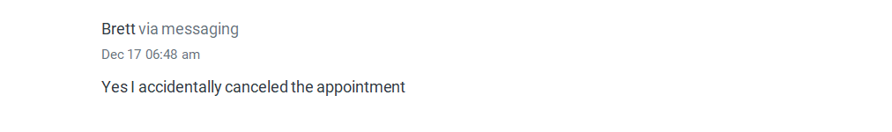

1. **Subject**: Brett Attendance Datasheet Displaying “USER_CANCEL” Dates And 17 December 2022 Actions.

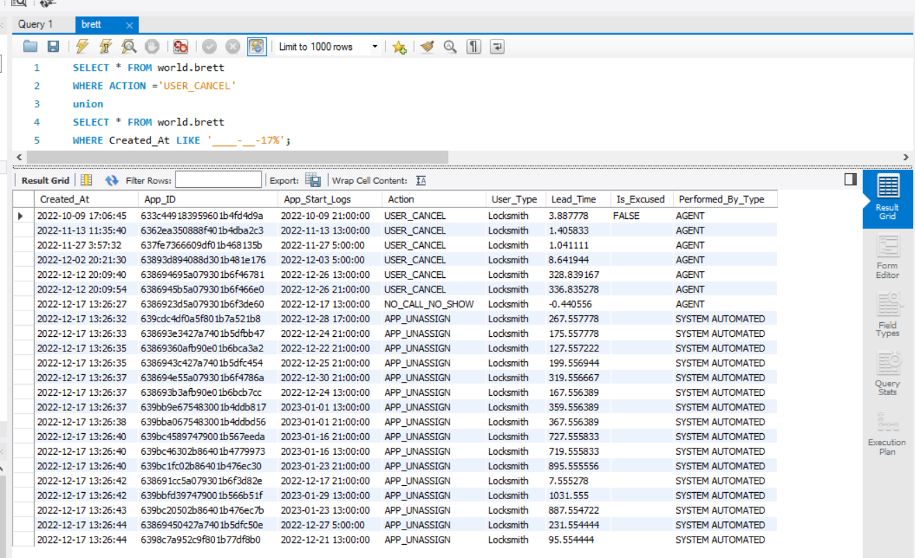

**Findings And Insights On Brett’s Account.**

1. Support Interactions And Management Email:
2. On the support interaction, December 17 2022 at 06:39 Brett stated that his phone died and he couldn’t notify for being late to work so

he “**IMMEDIATELY”** cancelled for the shift.

* My question is, how did he cancel for the shift after his phone had died.

On December 17 2022 at 06:48 he further stated that he accidentally cancelled for the appointment.

On the mail to the E-Connect Management at 3:18 pm 17 December 2022 he states that he accidentally cancelled due to car problem.

* My question is, did he accidentally cancel due to car problems or intentionally cancelled immediately due to being late after his phone died?, and how because his phone would have been dead?.

1. On the support interaction on 17 December 2022 – 06:42am. Brett seem to be aware of the organizations policies and regulations as he states

“Thank you, I don’t agree with attendant policy”.

On the Support Interaction, one of our agents Joy Gullaba at 06:44am on 17 December 2022 asked “Did you already fill out a dispute form?”.

At 06:45am on 17 December 2022 Brett replied stating: “No I did not, I’m not sure how to go about it”

_My question is how is Brett not aware of how to go about doing a form dispute, which is part of the organizations policies and regulations, but he is aware of the attendance policy?.

1. Brett Attendant Register.

Concerning Brett’s case on the 6th of December 2022 appointment cancellation , Brett’s appointment register displays that no appointment was present on 17 December 2022, but a NO_CALL_NO_SHOW is visible at 13:26:27 on this date.

Brett had 6 cancellations before the 17th of December 2022. 1 cancellation on the 9th of October 2022(3 hours before start time), 1 cancellation on the 13th of November 2022(1 hour before start time), 1 cancellation on the 27th of November 2022(1 hour before start time), 1 cancellation on the 2nd of December 2022(8 hours before start time), 2 cancellations on the 12th of December 2023(300 hours before start time)

**ANSWERING QUESTIONS FOR BRETT’s DATA**

1. Based on the data provided, would I upload the deactivation or reactivate the ESPs-Emergency Service Providers account?

Answer: I would deactivate Brett, our Emergency Service Providers Account.

1. In detail explain your reasoning:
2. **Sense of inauthenticity when communicating Support team**: Brett explains his reason on the support interaction for deactivation of account, as inability to report for being late due to phone dying, but then he was able to **intentionally immediately** cancel his shift.
3. **Sense of inauthenticity when communicating with the E-connect Management** : Brett explains his reason for being late to the E- Connect Manager as he **“accidentally”** cancelled due to car problems.
4. **Failure to adhere to rules and regulations:** On the support interaction, Brett told our agent that he doesn’t agree with the attendant policy, meaning he is well aware of the rules and regulations of the organization. Thus, after the agent asked if he filed a dispute, he replied with a NO, which in return if he had given the supporting documents for his dispute, reconsideration would have been an option.
5. **Attendance Penalties:** According to Brett’s attendant data sheet, he was penalized 3 times for cancelling an appointment within 8 hours, within 3 months, before he was penalized for the 4th time for a NO_CALL_NO_SHOW.

* Penalty 1 : 9th October 2022(Lead Time : 3.88).
* Penalty 2 : 13th November 2022(Lead Time: 1.40).
* Penalty 3 : 27th November 2022(Lead Time: 1.04).
* Penalty 4 : 17th December 2022(Lead Time: -0.44). NO_CALL_NO_SHOW.

1. Email response to Brett explaining my decision and reasoning.

Date : Sun, 18 Nov,2022, at 08:00am

From: Terms Team- Koketso Alex.

To: Brett(Arizona)

Subject: Account re-activation rejected.

Dear Brett thank you for reaching out to our E-Connect Management and support team for the reactivation of your account on the E-Connect platform.

You query was received and your account was reviewed, we are well aware that the platform has helped you provide for you family. Unfortunately, we will not be reactivating your account for inauthenticity, reason of the cancellation of your last shift. Whether it was intentional/accidental due to car problems or phone dying.

Failure to adhere to rules and regulations by not lodging a dispute with supporting documents for your shift cancellation, and being penalized 3 time in 2 months, and a 4th final penalty for a NO_CALL_NO_SHOW within this period.

Warm Regards

Terms Team

**Case 2: Ron McClain Account Deactivation Analysis**

1. **Subject** : Ron McClain’s support interaction.

**Time And Date** : Jan 06 2023 – 04:16 PM

**Issue**: Dispute Rejection.

**Cause**: Ron McClain family matters which led to account deactivation.

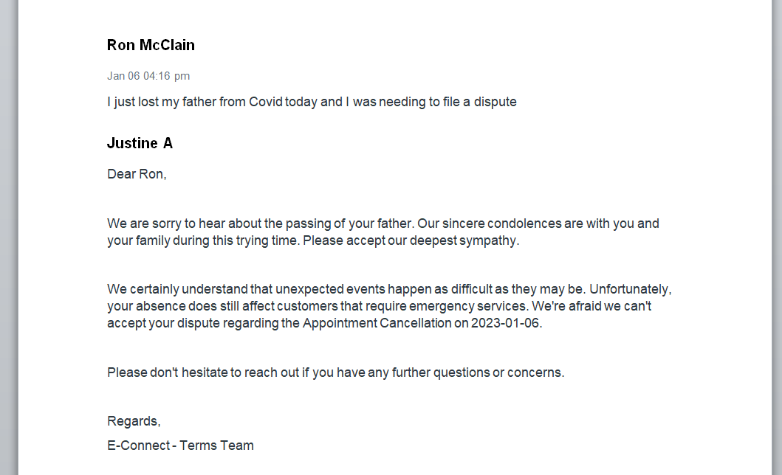

1. Subject: Ron McClain overall shift cancellation datasheet with and without disputes.

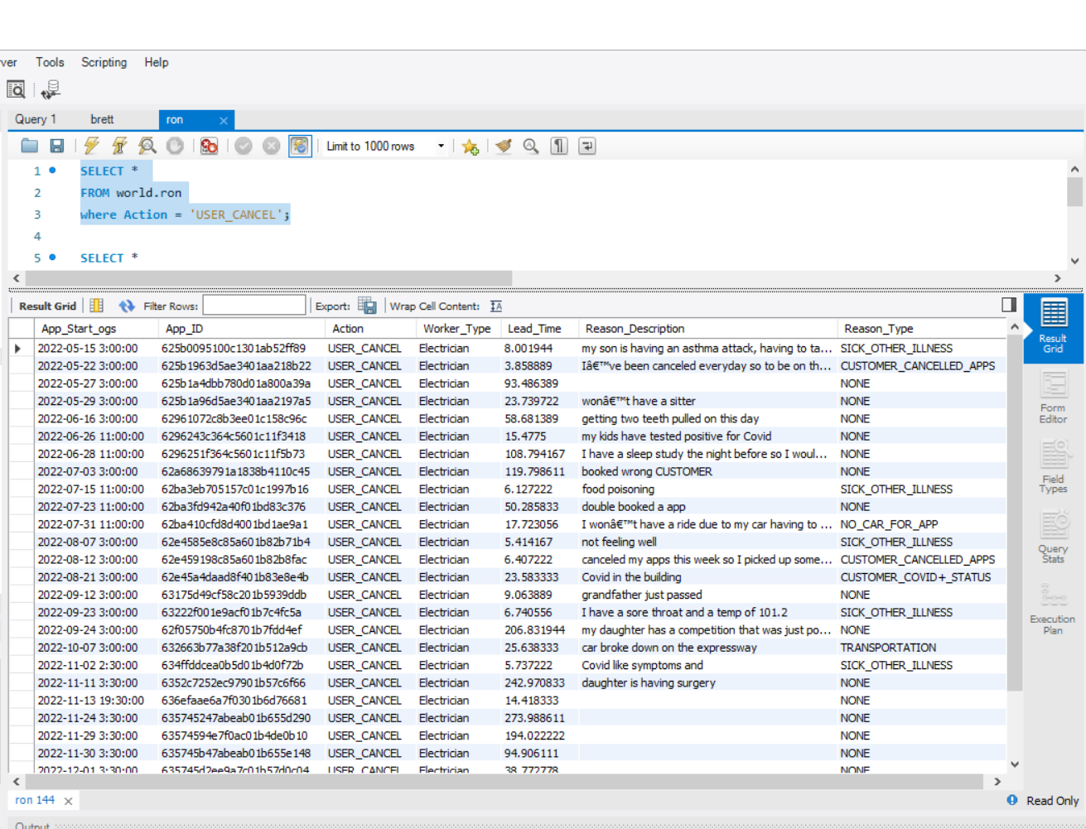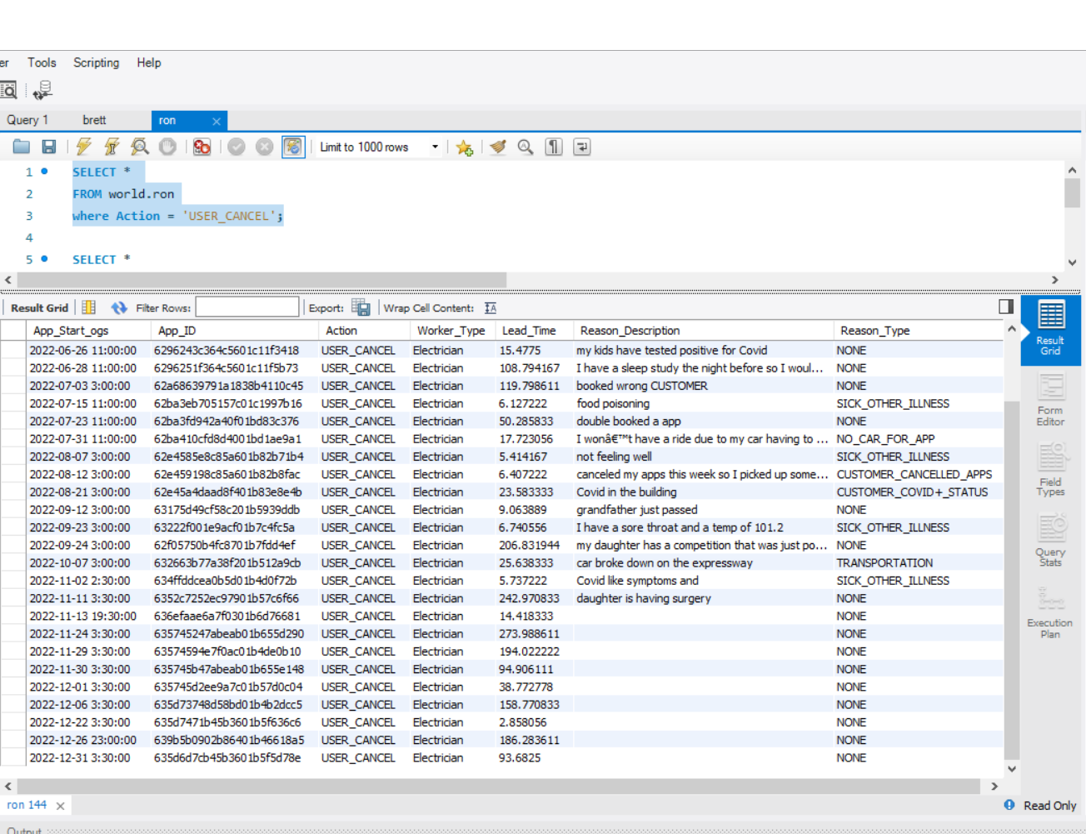

1. **Subject :**Ron McClain shift cancellation without disputes

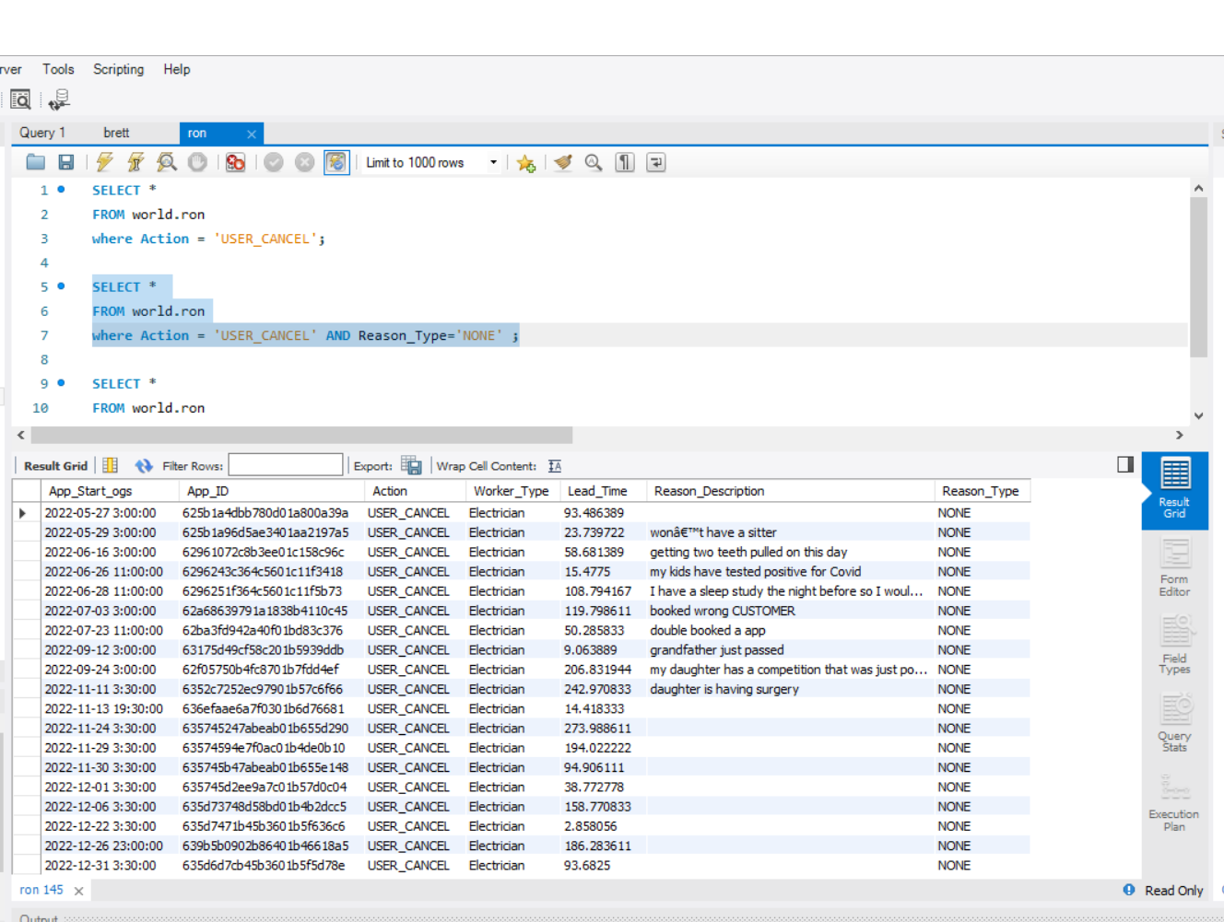

1. **Subject:** Ron McClain’s Attendance datasheet for January 2023.

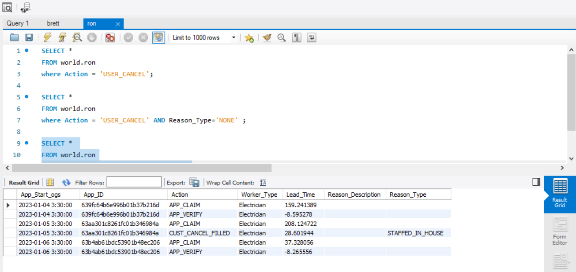

**Insight And Findings On Ron McClain’s Account.**

1. Concerning Ron McClain’s support interaction we owe him an apology for rejecting his dispute for his shift cancellation due to the fact that his attendance datasheet tells another story about why his dispute should be considered in order to reactivate his account.
2. Ron McClain’s attendance register with overall shift cancellation with and without disputes.

-**May 22, 2022,** Ron’s emergency customer cancelled on him 3 hours before his shift.

- **July 15, 2022.** Ron cancelled 6 hours before his shit due to food poisoning, and his dispute was accepted.

-**August 07,2022.** Ron cancelled his shift 5 hours before shift starting time due to a medical condition, and his dispute was accepted.

-**August 12, 2022.** Ron’s shift was cancelled 5 hours before shift starting time by his emergency customer.

-**November 2nd, 2022.** Ron cancelled his shift 5 hours before shift starting time due to a medical condition and his dispute was accepted.

-**December 22,2022.** Ron cancelled his shift 2 hours before his shift starting time without any dispute, which is the only penalty displayed on his datasheet.

All other cancellations were made in adherence to the shift cancellation rules and regulations. Which state that: “Shift cancellation within 5 minutes of accidentally booking a shift is allowed and, cancelling a shift 8 hours before starting the shift is allowed”.

1. Ron McClain’s attendance datasheet for the month of : May, June, July, August, September, November And December of 2022, where Ron McClain had cancelled shift.

* In the above mentioned months, Ron had cancelled shifts, during all these months besides December. He was able to cancel shifts in adherence to the rules and regulations of shift cancellation : “Cancelling 5 minutes before, after accidentally booking a shift and 8 hours before a shift start time”.
* During these months Ron had only one penalization on the month of December 22, 2022 for cancelling a shift 3 hours before the start of a shift without any dispute.

1. Ron McClain’s attendance datasheet for the month of January 2023.

-The observable datasheet for this month displays that Ron didn’t have any shift cancellation nor NO_CALL_NO_SHOW action, thus no account penalties.

**Answering Ron McClain’s Questions Based on Data.**

1. Based on all the data provided, would you uphold the deactivation or reactivate the ESPs account?

* Based on the data provided I would most certainly reactivate the ESPs account

1. Detail explanation and reasoning.

* I would certainly activate Ron McClain’s account due to the fact that, his cancellations follows disputes rules and regulations for starters. Secondly, his cancellations adhere to the rules and regulation of cancelling a shift 5 minutes before, after accidentally booking a shift, and cancelling a shift 8 hours before the shift’s start time. Lastly is because he has only been penalized once in the month of December out of all the 7-8 months, and there’s no sign of misconduct in the year of January 2023.

1. Email response to Brett explaining my decision and reasoning.

Date: January 7th 2024.

From: Terms Team-Koketso alex.

To: Tom McClain

Subject: Acceptance Of Account Activation.

Dear Ron McClain, thank you for reaching out to the E-Connect support team for the reactivation account, and yet we are still sending you our sincere condolences for the passing of your father.

You query was received and your account was reviewed, we would like to apologize on behalf of our support team agent, for rejecting to file your dispute and reactivate your account as your account data was misinterpreted.

Your account will be reactivated after discovering your adherence to providing supporting shift cancellation disputes regulations, shift cancellation period rules and regulation and only being penalized once, and not encountering any misconduct in the month of January 2023. We hope this mail will release some tension with the current situation you are in with your family.

Warm Regards

Terms Team – Koketso Alex